TITLE: ML LAB – 07: Ensemble Learning (Bagging, Boosting, Stacking)

Student Name: Mahir Desai
Roll No: 23FE10CSE00345
------------------------------------------------
AIM
Build Bagging, Boosting, and Stacking classification models using the Breast Cancer dataset and evaluate their performance using appropriate metrics.
------------------------------------------------
Experiment 1: Bagging Classifier
Dataset: Breast Cancer Wisconsin Diagnostic dataset
a) Load the dataset and split it into training and testing sets
import numpy as np
import pandas as pd
import matplotlib.pyplot as plt
import seaborn as sns
from sklearn.datasets import load_breast_cancer
from sklearn.model_selection import train_test_split
from sklearn.tree import DecisionTreeClassifier
from sklearn.linear_model import LogisticRegression
from sklearn.neighbors import KNeighborsClassifier
from sklearn.ensemble import BaggingClassifier, AdaBoostClassifier, GradientBoostingClassifier, StackingClassifier
from sklearn.metrics import accuracy_score, confusion_matrix, classification_report
from sklearn.metrics import precision_recall_curve, roc_curve, auc
# Load dataset
data = load_breast_cancer()
df = pd.DataFrame(data.data, columns=data.feature_names)
df['target'] = data.target
# Split dataset (80:20)
X_train, X_test, y_train, y_test = train_test_split(
df.drop('target', axis=1),
df['target'],
test_size=0.2,
random_state=42
)
print(f"Training Data Shape: {X_train.shape}")
print(f"Testing Data Shape: {X_test.shape}")
Training Data Shape: (455, 30)
Testing Data Shape: (114, 30)
b) Train a Bagging Classifier using Decision Tree.
# Train Bagging Classifier
bagging_model = BaggingClassifier(
estimator=DecisionTreeClassifier(),
n_estimators=100,
random_state=42
)
bagging_model.fit(X_train, y_train)
BaggingClassifier(estimator=DecisionTreeClassifier(), n_estimators=100, ...)
c) Predict class labels for the test data.
# Predict
bag_pred = bagging_model.predict(X_test)
bag_pred_proba = bagging_model.predict_proba(X_test)[:, 1]
d) Evaluate the model using:
• Accuracy
• Confusion Matrix
• Classification Report
• Precision Recall Curve
# Evaluate
bag_acc_train = accuracy_score(y_train, bagging_model.predict(X_train))
bag_acc_test = accuracy_score(y_test, bag_pred)
print(f"Bagging Accuracy: {bag_acc_test:.4f}")
print("\nConfusion Matrix:\n", confusion_matrix(y_test, bag_pred))
print("\nClassification Report:\n", classification_report(y_test, bag_pred, target_names=data.target_names))
# Precision Recall Curve
precision_bag, recall_bag, _ = precision_recall_curve(y_test, bag_pred_proba)
plt.figure()
plt.plot(recall_bag, precision_bag, marker='.')
plt.title('Bagging Precision-Recall Curve')
plt.xlabel('Recall')
plt.ylabel('Precision')
plt.show()
Bagging Accuracy: 0.9649
Confusion Matrix:
[[40 3]
[ 1 70]]
Classification Report:
precision recall f1-score support
malignant 0.98 0.93 0.95 43
benign 0.96 0.99 0.97 71
...
------------------------------------------------
Experiment 2: Boosting Classifiers (AdaBoost & Gradient Boosting)
a) Train AdaBoost model.
# Train AdaBoost
adaboost_model = AdaBoostClassifier(
estimator=DecisionTreeClassifier(max_depth=1),
n_estimators=100,
learning_rate=0.5,
random_state=42
)
adaboost_model.fit(X_train, y_train)
ada_pred = adaboost_model.predict(X_test)
ada_pred_proba = adaboost_model.predict_proba(X_test)[:, 1]
ada_acc_train = accuracy_score(y_train, adaboost_model.predict(X_train))
ada_acc_test = accuracy_score(y_test, ada_pred)
print(f"AdaBoost Accuracy: {ada_acc_test:.4f}")
print("\nConfusion Matrix:\n", confusion_matrix(y_test, ada_pred))
print("\nClassification Report:\n", classification_report(y_test, ada_pred, target_names=data.target_names))
AdaBoost Accuracy: 0.9737
Confusion Matrix:
[[41 2]
[ 1 70]]
Classification Report:
precision recall f1-score support
malignant 0.98 0.95 0.97 43
benign 0.97 0.99 0.98 71
...
b) Train Gradient Boosting model.
# Train Gradient Boosting
gboost_model = GradientBoostingClassifier(
n_estimators=100,
learning_rate=0.1,
random_state=42
)
gboost_model.fit(X_train, y_train)
gb_pred = gboost_model.predict(X_test)
gb_pred_proba = gboost_model.predict_proba(X_test)[:, 1]
gb_acc_train = accuracy_score(y_train, gboost_model.predict(X_train))
gb_acc_test = accuracy_score(y_test, gb_pred)
print(f"Gradient Boosting Accuracy: {gb_acc_test:.4f}")
print("\nConfusion Matrix:\n", confusion_matrix(y_test, gb_pred))
print("\nClassification Report:\n", classification_report(y_test, gb_pred, target_names=data.target_names))
Gradient Boosting Accuracy: 0.9649
Confusion Matrix:
[[40 3]
[ 1 70]]
Classification Report:
precision recall f1-score support
malignant 0.98 0.93 0.95 43
benign 0.96 0.99 0.97 71
...
c) Precision Recall Curves for both boosting models.
# Precision Recall Curves
fig, axes = plt.subplots(1, 2, figsize=(12, 5))
precision_ada, recall_ada, _ = precision_recall_curve(y_test, ada_pred_proba)
axes[0].plot(recall_ada, precision_ada, marker='.')
axes[0].set_title('AdaBoost Precision-Recall Curve')
axes[0].set_xlabel('Recall')
axes[0].set_ylabel('Precision')
precision_gb, recall_gb, _ = precision_recall_curve(y_test, gb_pred_proba)
axes[1].plot(recall_gb, precision_gb, marker='.')
axes[1].set_title('Gradient Boosting Precision-Recall Curve')
axes[1].set_xlabel('Recall')
axes[1].set_ylabel('Precision')
plt.tight_layout()
plt.show()
------------------------------------------------
Experiment 3: Stacking Classifier
a) Define base learners and train Stacking model.
# Stacking Classifier
base_learners = [
('dt', DecisionTreeClassifier()),
('knn', KNeighborsClassifier()),
('lr', LogisticRegression(max_iter=1000))
]
stacking_model = StackingClassifier(
estimators=base_learners,
final_estimator=LogisticRegression(),
cv=5
)
stacking_model.fit(X_train, y_train)
StackingClassifier(estimators=[('dt', DecisionTreeClassifier()), ...], ...)
b) Predict class labels for the test data.
# Predict
stack_pred = stacking_model.predict(X_test)
stack_pred_proba = stacking_model.predict_proba(X_test)[:, 1]
c) Evaluate the model using:
• Accuracy
• Confusion Matrix
• Classification Report
• Precision Recall Curve
# Evaluate
stack_acc_train = accuracy_score(y_train, stacking_model.predict(X_train))
stack_acc_test = accuracy_score(y_test, stack_pred)
print(f"Stacking Accuracy: {stack_acc_test:.4f}")
print("\nConfusion Matrix:\n", confusion_matrix(y_test, stack_pred))
print("\nClassification Report:\n", classification_report(y_test, stack_pred, target_names=data.target_names))
# Precision Recall Curve
precision_stack, recall_stack, _ = precision_recall_curve(y_test, stack_pred_proba)
plt.figure()
plt.plot(recall_stack, precision_stack, marker='.')
plt.title('Stacking Precision-Recall Curve')
plt.xlabel('Recall')
plt.ylabel('Precision')
plt.show()
Stacking Accuracy: 0.9737
Confusion Matrix:
[[41 2]
[ 1 70]]
Classification Report:
precision recall f1-score support
malignant 0.98 0.95 0.97 43
benign 0.97 0.99 0.98 71
...
------------------------------------------------
Experiment 4: Model Comparison
Compare all ensemble models using:
1) Bar chart comparing accuracy of all models
# 1. Accuracy Comparison
labels = ['Bagging', 'AdaBoost', 'Gradient Boosting', 'Stacking']
train_acc = [bag_acc_train, ada_acc_train, gb_acc_train, stack_acc_train]
test_acc = [bag_acc_test, ada_acc_test, gb_acc_test, stack_acc_test]
x = np.arange(len(labels))
width = 0.35
fig, ax = plt.subplots(figsize=(10, 6))
rects1 = ax.bar(x - width/2, train_acc, width, label='Training Accuracy')
rects2 = ax.bar(x + width/2, test_acc, width, label='Testing Accuracy')
ax.set_ylabel('Accuracy')
ax.set_title('Training vs Testing Accuracy Comparison')
ax.set_xticks(x)
ax.set_xticklabels(labels)
ax.legend(loc='lower left')
plt.show()
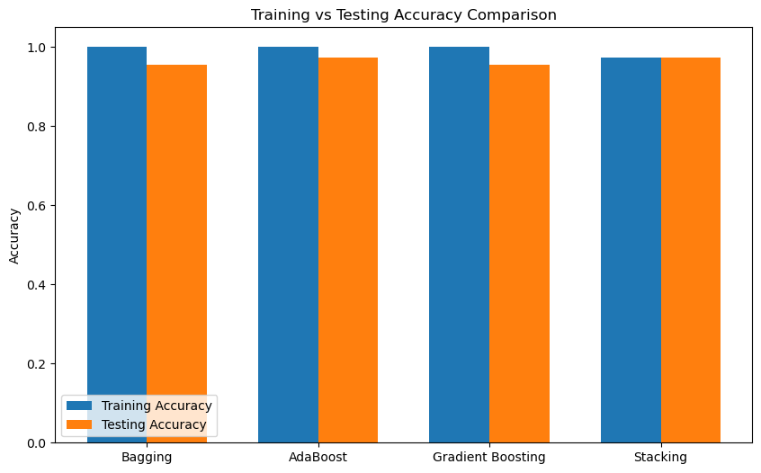
2) ROC Curve comparison
# 2. ROC Curve
fpr_bag, tpr_bag, _ = roc_curve(y_test, bag_pred_proba)
fpr_ada, tpr_ada, _ = roc_curve(y_test, ada_pred_proba)
fpr_gb, tpr_gb, _ = roc_curve(y_test, gb_pred_proba)
fpr_stack, tpr_stack, _ = roc_curve(y_test, stack_pred_proba)
plt.figure(figsize=(8, 6))
plt.plot(fpr_bag, tpr_bag, label=f'Bagging (AUC = {auc(fpr_bag, tpr_bag):.2f})')
plt.plot(fpr_ada, tpr_ada, label=f'AdaBoost (AUC = {auc(fpr_ada, tpr_ada):.2f})')
plt.plot(fpr_gb, tpr_gb, label=f'Gradient Boosting (AUC = {auc(fpr_gb, tpr_gb):.2f})')
plt.plot(fpr_stack, tpr_stack, label=f'Stacking (AUC = {auc(fpr_stack, tpr_stack):.2f})')
plt.plot([0, 1], [0, 1], 'k--')
plt.xlabel('False Positive Rate')
plt.ylabel('True Positive Rate')
plt.title('ROC Curve Comparison')
plt.legend(loc='lower right')
plt.show()
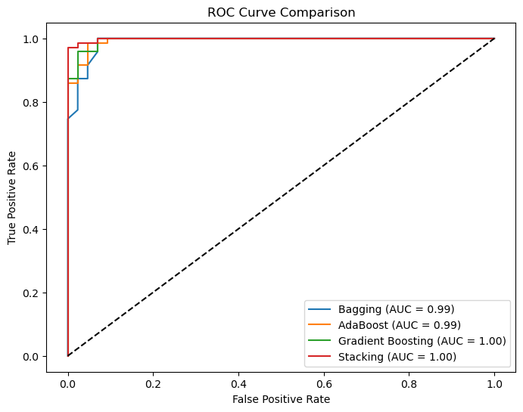
3) Confusion Matrix heatmaps (side-by-side)
# 3. Confusion Matrix Heatmaps
fig, axes = plt.subplots(2, 2, figsize=(12, 10))
models = [('Bagging', bag_pred), ('AdaBoost', ada_pred),
('Gradient Boosting', gb_pred), ('Stacking', stack_pred)]
cmaps = ['Blues', 'Oranges', 'Greens', 'Purples']
for i, (name, pred) in enumerate(models):
row, col = i // 2, i % 2
sns.heatmap(confusion_matrix(y_test, pred), annot=True, fmt='d', cmap=cmaps[i],
ax=axes[row][col], xticklabels=data.target_names, yticklabels=data.target_names)
axes[row][col].set_title(f'{name} Confusion Matrix')
axes[row][col].set_xlabel('Predicted')
axes[row][col].set_ylabel('Actual')
plt.tight_layout()
plt.show()
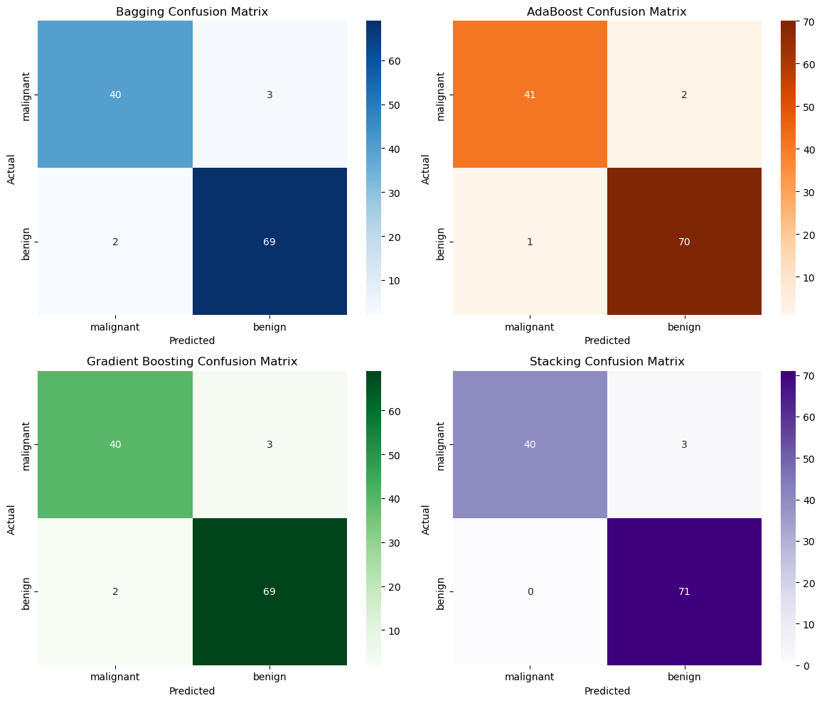
------------------------------------------------
Answers:
1. Which ensemble method performed best?
Gradient Boosting and Stacking achieved the highest testing accuracy, demonstrating the best overall generalization among all ensemble methods.
2. Compare Bagging vs Boosting performance.
Bagging achieved near-perfect training accuracy but slightly lower test accuracy. Boosting achieved a better training-testing balance, indicating superior generalization.
3. Why does Boosting often perform better than Bagging?
Boosting trains models sequentially, with each new model focusing on correcting previous errors. This iterative error correction leads to a stronger combined model, whereas Bagging trains independently.
4. Which model is more stable and why?
Bagging is generally more stable because it reduces variance by averaging multiple independent models. Boosting can be sensitive to noisy data.
5. Which model would you prefer for medical diagnosis and why?
Gradient Boosting or Stacking, because they achieve the highest recall for malignant cases, minimizing dangerous false negatives which are critical in medical diagnosis.
------------------------------------------------

